New Kubernetes Project solution.

Firstly we will install docker,kubectl and minikube in our ubuntu system.

Once the setup is done ,check whether it is up and running properly.

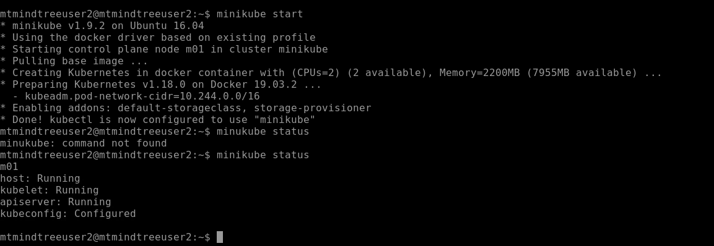



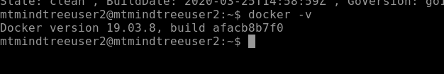

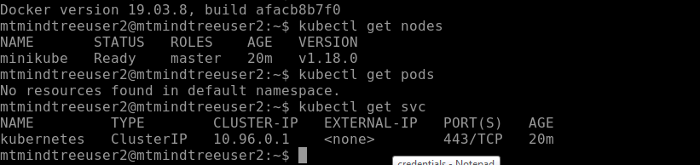

Now we will be cloning the Microservcice based NodeJS Application source code from the internet.

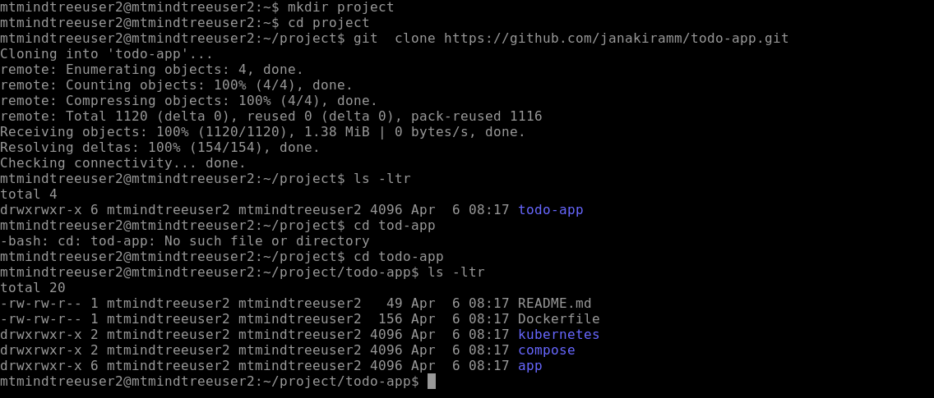

To create docker image we need to run the docker file

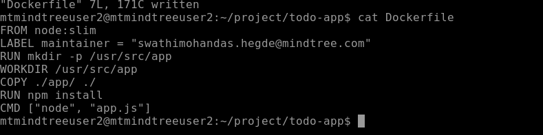

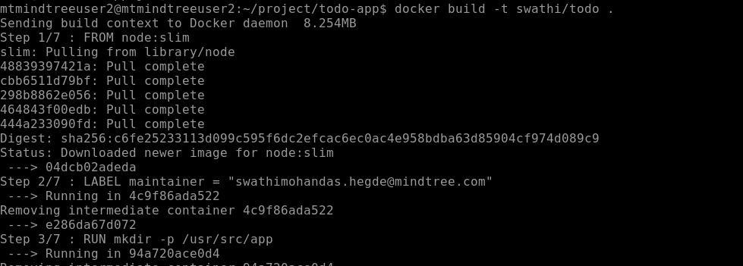

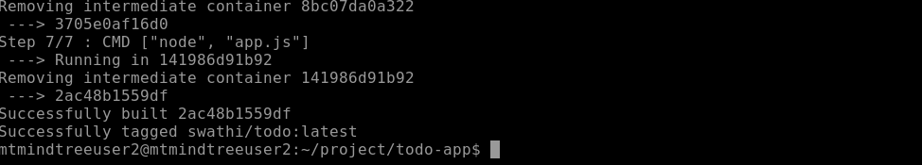

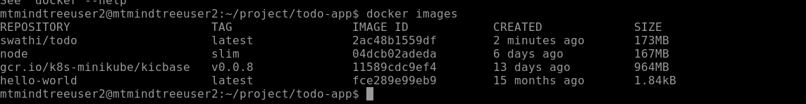

Could see that the image has been build with the name swathi/todo:latest

Now we will be pushing the image to docker hub

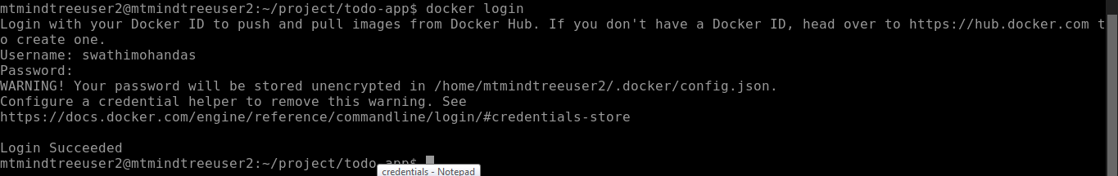

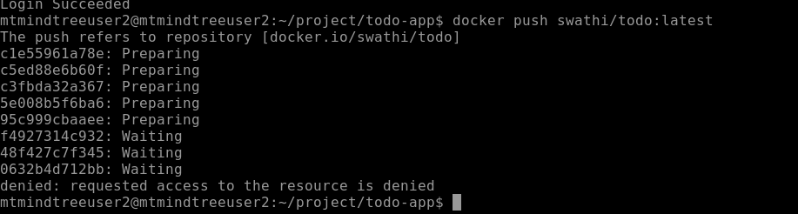

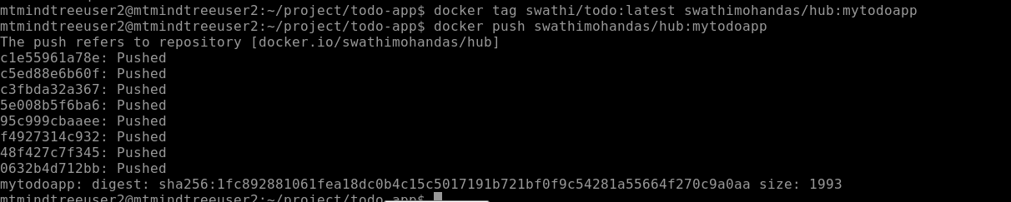

We could see the images in the dockerhub registry now

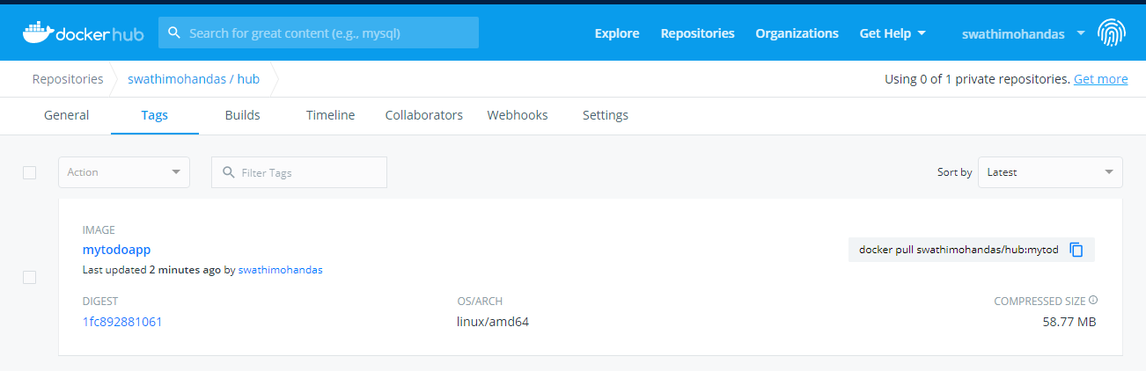

We want our kubernetes cluster to acess the image,so we what ever we have build on the dev mahine should be made available to kubernetes cluster ,pushing it into the dockerhub registry makes the images centrally accessible.

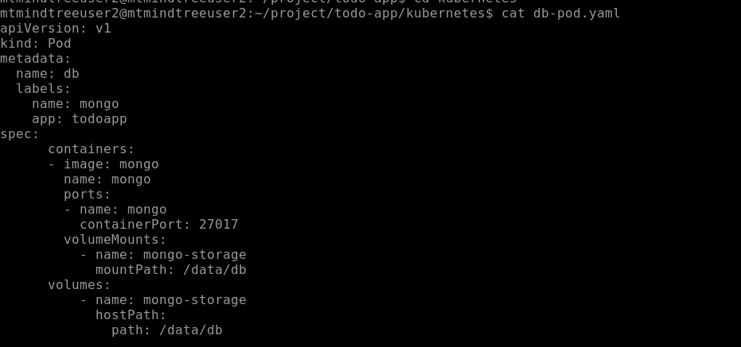

Now we will be creating the db pod i.e fisrte pod of our cluster.

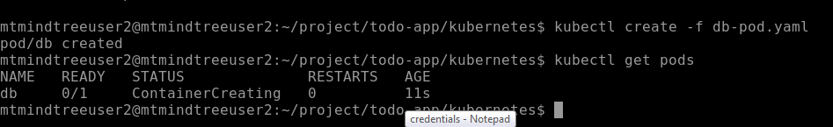

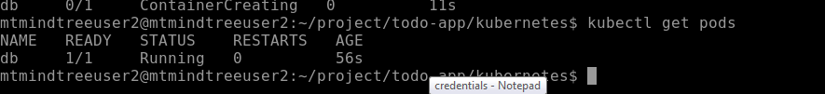

Kubectl logs db :to check the db logs

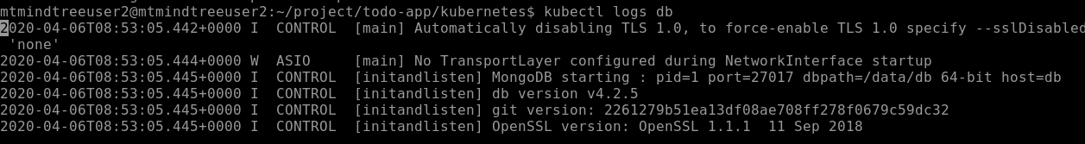

To inspect the pod

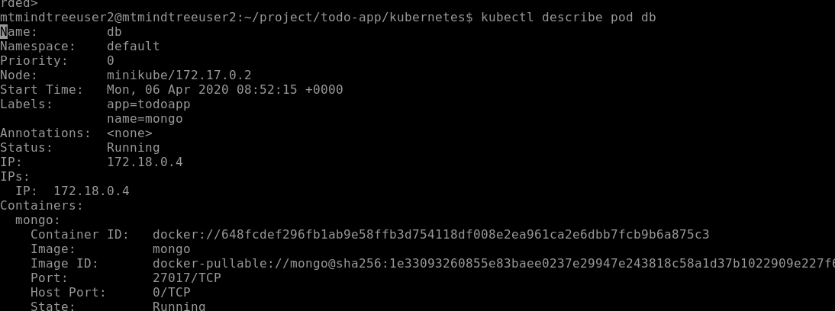

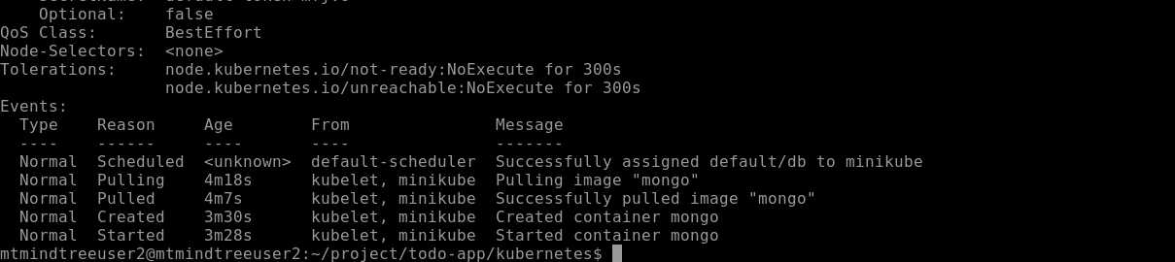

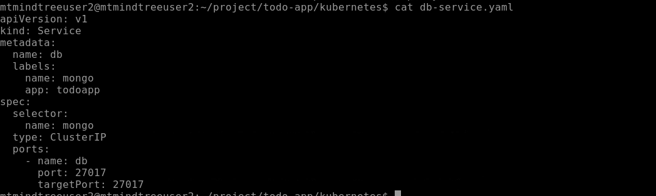

Now to create db-service,execute below commands

